**Reading List**

**2025-2026**

**

**Students Entering** **First Grade**

**Suggested Summer Reading Strategies and Books**

**Reading Strategies to Practice:**

● Have a regular time and place to read each day.

● Find a good fit book using the “Five Finger” method. Five unknown words on a page is too difficult. One unknown word is too easy. Two or three words can challenge you but not frustrate you.

● Practice rereading favorite books to improve your fluency.

● Take a picture walk and get your mind ready to read.

● Retell the story to show your comprehension: Tell what happened first, next, then, and last.

● Don’t be afraid to pick a new book. If it is too challenging, read it with an adult and practice your oral comprehension.

● Apply as many strategies as you can to figure out unknown words.

● When you get to an unknown word: Break it up, don’t make it up!

● Practice your red words.

● Review your letters and sounds! Use them to build words you know.

● Find a chunk or part of a word that you know: -ing, -at, sh-, etc.

● Look closely at the pictures for clues to unknown words.

**Recommended Authors:**

These are authors that might interest your child, though reading books of interest by any author of choice is encouraged.

* *Biscuit* Series – Alyssa Capucilli
* *Bear* Series – Karma Wilson
* Dr.Seuss books
* *Duck on a Bike*, *David Series*, *How I Became a Pirate* – David Shannon
* *Fly Guy* Series – Tedd Arnold
* *Frog and Toad* books – Arnold Lobel
* *Henry and Mudge* books – Cynthia Rylant
* *I Can Read* Book Club books
* *Max and Ruby* Series – Rosemary Wells
* *Mother Bruce* series – Ryan T. Higgins
* *Penelope T.Rex* Series – Ryan T. Higgins
* *Piggie & Elephant*, *Pigeon*, *Duckling*, *Knuffle Bunny* – Mo Willems
* *Pete the Cat* series – Eric Litwin (original books) / Kimberly & James Dean (later books)
* *Harry Gets Ready for School*, *Buzzy Series* – Harriet Ziefert
* *If You Give a Mouse a Cookie* Series – Laura Numeroff

**Students Entering Second Grade**

**Suggested Summer Reading List**

**Author Title**

Adler, David Cam Jensen (Series)

Axelrod, Amy Pigs Will Be Pigs

Brown, Marc Arthur (Series)

Carle, Eric The Mixed-Up Chameleon

Cole, Joanna Bully Trouble

My Puppy is Born

The Magic School Bus (Series)

Johnston-Adams, Barbara The Go-Around Dollar

Kellogg, Steven Can I Keep Him?

Lewin, Ted Market!

Meddaugh, Susan Martha Speaks

Martha Walks the dog

Myller, Rolf How Big is a Foot?

Rylant, Cynthia Poppleton

Henry and Mudge (Series)

Sharmat, Marjorie Weinman I'm Terrific

Nate The Great (Series)

Slater, Teddy Just a Minute!

Wells, Rosemary McDuff Moves In

Please use this suggested Summer Reading List as a guide for choosing books this summer. These choices will help your child, along with introducing the types of literature included in our second grade reading program. We recommend that you make reading a part of your summer activities.

While you are reading, please think about sequencing. What happens first, next, then, and finally in your story? Please keep a record of any books read. We will have a follow-up activity when children return to school.

**Students Entering Third Grade**

Recommended Summer Reading List

Summer is a wonderful time of the year for students to read literature for pleasure and to nurture a love for reading. The purpose of the summer reading program is to encourage students to become lifelong readers and to provide fun and engaging ways to build their independent reading skills. Literature that sparks a child’s curiosity, humor, and interest is more likely to keep your child reading, so this list provides suggestions of popular books and series to help you get started. We hope that you and your child have a wonderful time enjoying literature this summer!

**Books Recommended By Current Third Graders:**

* Wishtree by Katherine Applegate
* Wild Summer by James duBern
* Three Strike Summer by Skyler Schrempp
* Stella by McCall Hoyle
* My Weird School by Dan Gutman
* I Survived by Lauren Tarshis
* Who Was? or What Was? Series
* The Bad Guys by Aaron Blabey

**Book Series:**

* Magic Treehouse by Mary Pope Osborne
* Ivy & Bean by Annie Barrows
* Press Start by Thomas Flintham
* Diary of a Pug by Kyla May
* Owl Diaries by Rebecca Elliott
* The Kingdom of Wrenly by Jordan Quinn
* The Last Firehawk by Katrina Charman
* The Nevergirls by Kiki Thorpe
* The Pets Rule by Susan Tan
* Eerie Elementary by Jack Chabert
* Most Valuable Player Series MVP by David A. Kelly
* Catkid Comic Club by Dave Pilkey
* Dog Man by Dave Pilkey

4th Grade Summer Reading Suggestions

The intent of summer reading is to motivate, challenge and entertain children in order to encourage life-long reading habits. Due to the independent nature of reading, students should select books, which are of interest to them and adequately reflect their reading ability. Below please find a list of books that students often find engaging:

Hatchet - Gary Paulsen

Frindle - Andrew Clements

City of Ember - Jeanne DuPrau

The Wish Giver- Brian Brittain

Because of Winn Dixie - Kate DiCamillo

Stone Fox - John Gardiner

James and the Giant Peach - Roald Dahl

Tales of the 4th Grade Nothing - Judy Blume

Snow Treasure - Marie McSwigan

Shiloh - Phyllis Reynolds Naylor

Hidden Talents - David Lubar

These books represent books that we know students have enjoyed in past years. Remember reading should be student centered and all children must be encouraged to read from a variety of genres.

**Summer Reading List**

**Fifth Grade Summer Reading**

The summer reading goal for students entering fifth grade is **to read 2-3 books of their choice.** Students should also spend time enjoying nonfiction articles from newspapers or magazines! See below for some suggestions or ideas. Happy Reading!

**Books:**

Students can explore a great list of fifth-grade titles at:

[**5th Grade Reading List Books**](https://www.goodreads.com/shelf/show/5th-grade-reading-list)

Click on individual titles to read a summary!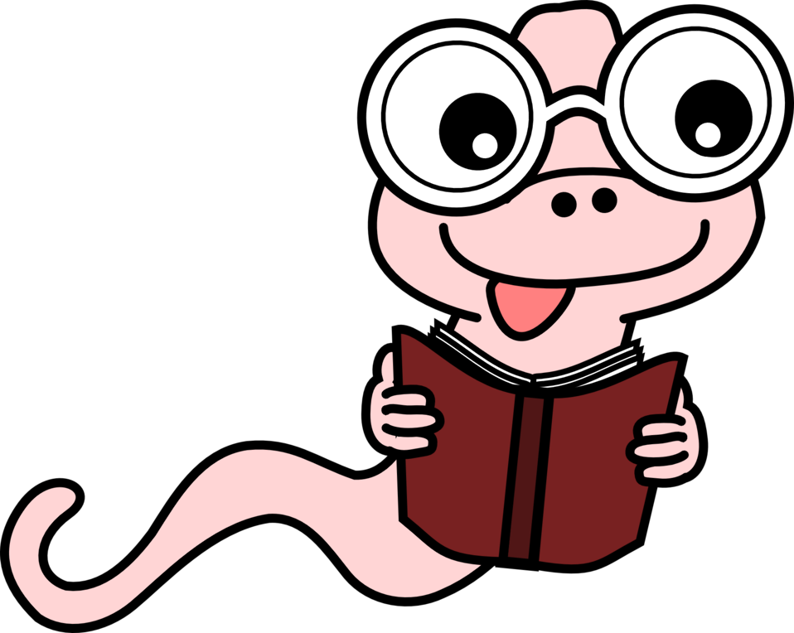

Students can explore parent favorites at:

[**Parent-Choice**](https://www.parents.com/fun/entertainment/books/)

**Nonfiction Reading:**

[**TIME for Kids | Articles**](https://www.timeforkids.com/g56)

[**National Geographic Kids**](https://kids.nationalgeographic.com/)

[**Kids Discover Online: Home**](https://online.kidsdiscover.com/)

**Websites:**

[**Storyline Online**](http://www.storylineonline.net/)

[**Spelling Practice and Games**](http://www.education.com/games/spelling/)

[**Freedom HomeSchooling ILA**](https://freedomhomeschooling.com/complete-language-arts/)

**The following books will be used as part of the 5th grade classroom curriculum, including read-aloud and book clubs.**  They may choose from this list for summer reading, but please **do not read the books in bold print** because they may be read aloud by the teacher.

**Old Yeller by Fred Gipson**

**Tangerine by Edward Bloor**

**Fish in a Tree by Lynda Mullaly Hunt**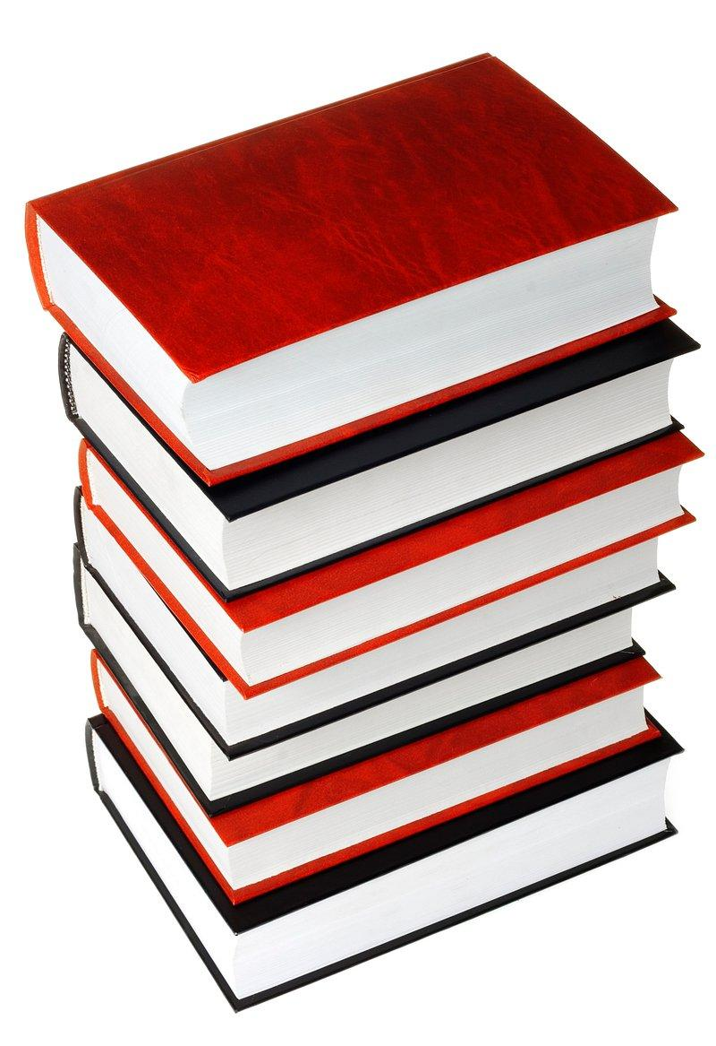

**Hoot by Carl Hiaasen**

Bud, Not Buddy by Christopher Paul Curtis

Hatchet by Gary Paulsen

The Westing Game by Ellen Raskin

Julie of the Wolves by Jean Craighead George

Island of the Blue Dolphins by Scott O’Dell

Maniac Magee by Jerry Spinelli

Ella Enchanted by Gail Carson Levine

The Lightning Thief by Rick Riordan

Tale of Despereaux by Kate DiCamillo

Al Capone Does My Shirts by Gennifer Choldenko

Game Changers by Mike Lupica

Tuck Everlasting by Natalie Babbitt

The One & Only Ivan by Katherine Applegate

The Giver by Lois Lowry

Holes by Louis Sachar

11 Birthdays by Wendy Mass

The Witches by Roald Dah

Students Entering **Grades 6-8**

**Summer Reading Lists**

Below is a list of **suggested** authors andtitles recommended by teachers, librarians, and students. Read **at least three different books** from **two different genres** over the summer. There may be written responses and/or projects involving these books in your ILA class during the month of September. You may find that using sticky notes to mark the important parts of the book helps you to keep track of your thinking.

Books read during the summer will count toward your first marking period reading requirement.

Fiction

● Andrew Clements: *Things Not Seen*

● Jon Scieska: *Guys Read: Funny Business, Thriller*, etc.

● Gary D. Schmidt: *The Wednesday Wars, Okay for Now,* etc*.*

● Jerry Spinelli *Crash, Stargirl,* etc*.*

● Joan Bauer: *Rules of the Road,* etc*.*

● Mike Lupica: *Hero, Summer Ball,* etc*.*

● Gordon Korman

● Walter Dean Myers

● Avi

● Gary Paulsen

● Pam Munoz Ryan

● W. Bruce Cameron, *A Dog’s Purpose*

Science Fiction/Fantasy

● Tony DiTerlizzi: *The Search for WondLA, A Hero for WondLa*

● Rick Riordan: *Percy Jackson and the Olympians, Kane Chronicles*

● Suzanne Collins: *Gregor the Overlander* series

● Ally Condie: *Matched* series

● James Dashner: *Maze Runner* series

● Veronica Roth: *Divergent* series

● Christopher Paolini: *Eragon* series

● Neal Shusterman: *Unwind* series*, Scythe,* etc.

Historical Fiction

● Andrea Pinckney*: Bird in a Box*

● Gloria Whelan*: Listening for Lions*

● Joseph Bruchac*: Code Talkers*

● Markus Zusak: *The Book Thief*

● Frances O’Roark Dowell : *Shooting the Moon*

● Clare Vanderpool*: Moon over Manifest*

● Harry Mazer: *Heroes Don’t Run*, etc.

● Margaret Peterson Haddix: *Uprising*

● Kimberley Brubaker Bradley: *The War that Changed my Life*

Mystery

● Trenton Lee Stewart: *The Extraordinary Education of Nicholas Benedict ( The Mysterious Benedict Society)*

● Wendelin Van Draanen*: Sammy Keyes(series)*

● Anthony Horowitz: *Alex Rider(*series*)*

● Phyllis Reynolds Naylor*: Jade Green: A Ghost Story*

● Chris Grabenstein

● Margaret Peterson Haddix: *Found* series, etc*.*

● Peg Kehret: *The Ghost’s Grave, Abduction,* etc*.*

● Mary Downing Hahn: *Deep, Dark and Dangerous,* etc*.*

● Ally Carter: *I’d Tell you I Love you, but Then I’d have to Kill You* series

Informational Reading

● Marc Aronson: *Trapped: How the World Rescued 33 Miners from 2,000 Feet Below the Chilean Desert* , etc.

● Jim Murphy: *Blizzard*

● Jennifer Armstrong*: Shipwreck at the Bottom of the World*

● James Giblin Cross*: Good Brother, Bad Brother: The Story of John Wilkes Booth and Edwin Booth*

● Melba Pattillo Beals: *Warriors Don’t Cry*

● Steve Sheinkin, *Bomb*, etc.

Biography :

● Julia Alvarez*: Before We Were Free*

● Sid Fleishman: *Escape the Story of the Great Houdini*

● Ralph Fletecher: *Marshfield Dreams*

● Eloise Greefield*: Childtimes*

● Russell Friedman*: Lincoln a Photobiography*

● Candace Fleming: *The Great and Only Barnum: The Tremendous, Stupendous Life of Showman P.T. Barnum*

● Carla Killough: *Something Out of Nothing: Marie Curie and Radium*

● Michael Lewis: *The Blind Side*

● Wicked History series

● Leon Walter Tillage:  *Leon’s Story*

● Ann Petry: *Harriet Tubman, Conductor on the Underground Railroad*

● Anne Frank, *Diary of a Young Girl*

● Roald Dahl, *Boy*

● Jerry Spinelli, *Knots in my Yo-yo String*

● Gary Paulsen: *Guts*, *My Life in Dog Years*, *How Angel Peterson got his Name*, etc.